Name – Akshat Bhargava

Roll no – 22563

DS – SL3

Prac 3

Code:

1. Import libraries and load ‘Iris.csv’ dataset

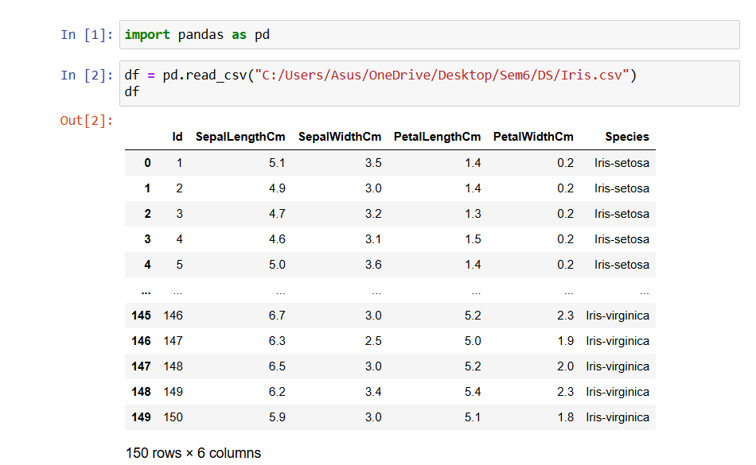

1. Provide summary statistics (mean, median, minimum, maximum, standard deviation) for a dataset (age, income etc.) with numeric variables grouped by one of the qualitative (categorical) variables.

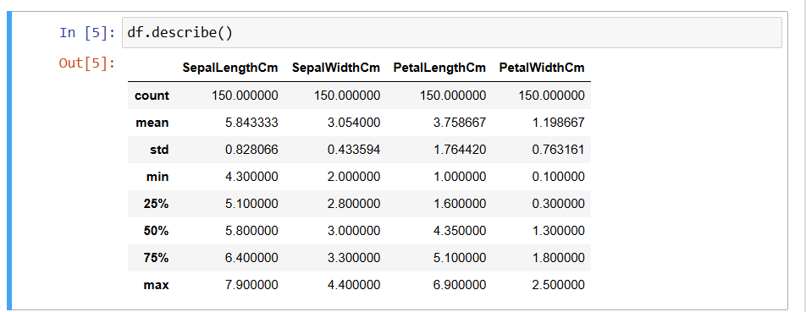

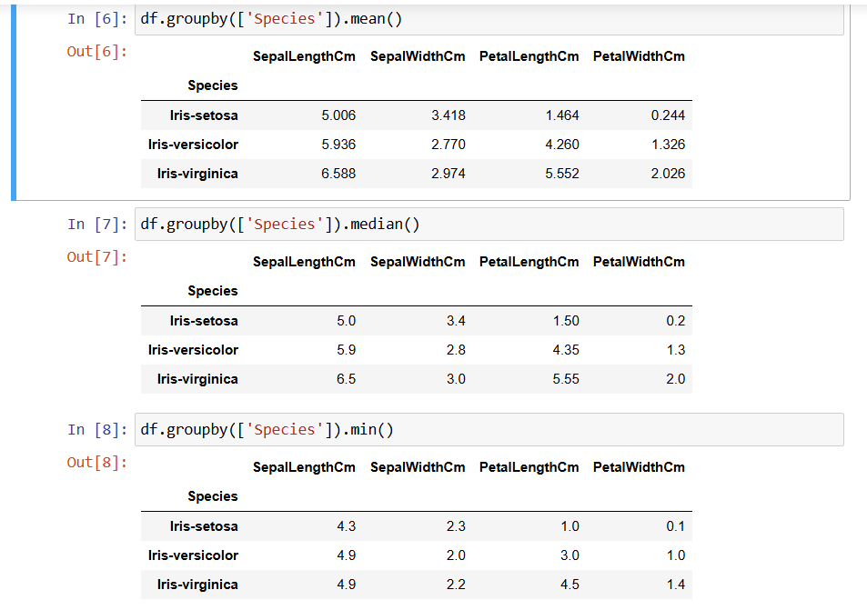

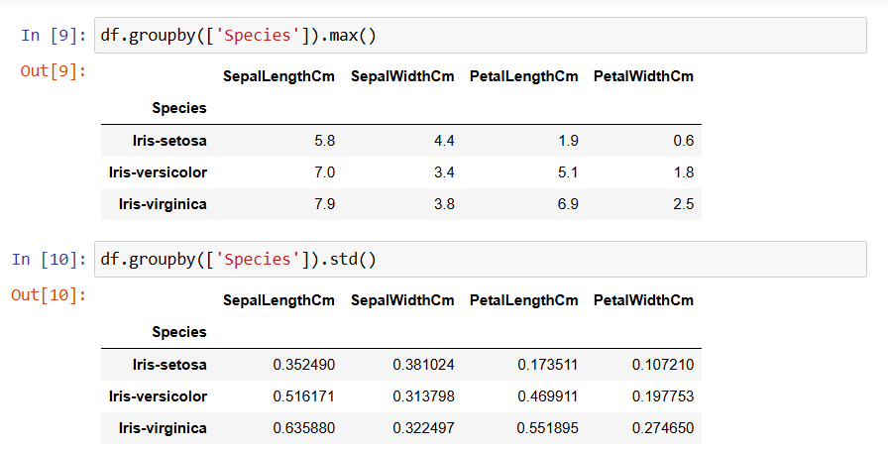

1. Write a Python program to display some basic statistical details like percentile, mean, standard deviation etc. of the species of ‘Iris-setosa’, ‘Iris-versicolor’ and ‘Iris-versicolor’ of iris.csv dataset.

